Iterator Pattern
# Source: AI Source: Provided by: [Data Path: Persons Table -> ID Column: 1, Name_En Column: Motasem Essam] -> From: [ChatGPT] on [1/23/2026]
The Iterator Pattern provides a way to access elements of a collection sequentially without exposing its underlying structure.
👉 Think of it like a TV remote for channels: you can go next/previous without knowing how channels are stored internally.

🔑 Key Points
# Source: AI Source: Provided by: [Data Path: Persons Table -> ID Column: 1, Name_En Column: Motasem Essam] -> From: [ChatGPT] on [1/23/2026]
• Provides a standard way to traverse collections
• Hides internal representation of data structures
• Supports multiple traversal strategies
• Promotes encapsulation

❌ Bad Example
# Source: AI Source: Provided by: [Data Path: Persons Table -> ID Column: 1, Name_En Column: Motasem Essam] -> From: [ChatGPT] on [1/23/2026]
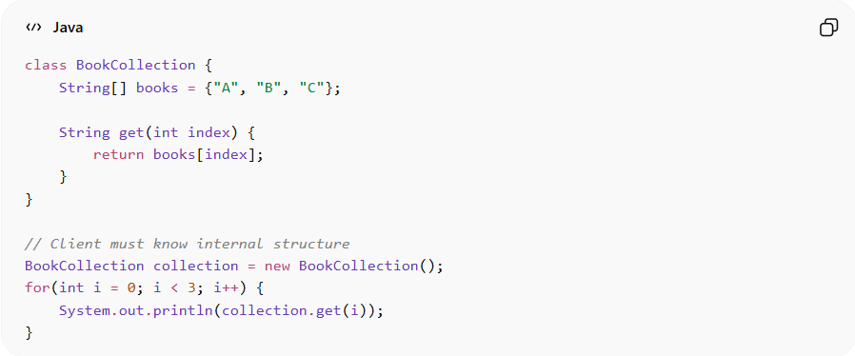
class BookCollection {
String[] books = {"A", "B", "C"};

String get(int index) {
return books[index];
}
}

// Client must know internal structure
BookCollection collection = new BookCollection();
for(int i = 0; i < 3; i++) {
System.out.println(collection.get(i));
}
Problems:
• Exposes internal structure (array)
• Not flexible if structure changes (e.g., to list)
• Duplicates traversal logic

✅ Good Example
# Source: AI Source: Provided by: [Data Path: Persons Table -> ID Column: 1, Name_En Column: Motasem Essam] -> From: [ChatGPT] on [1/23/2026]
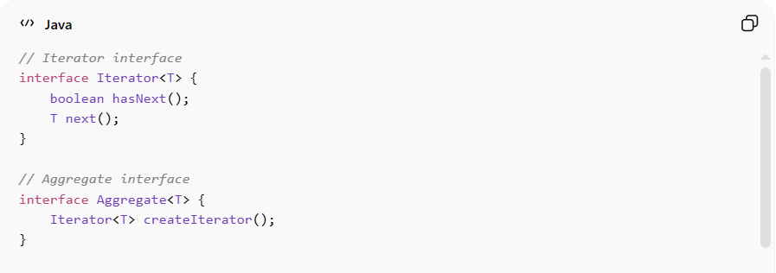
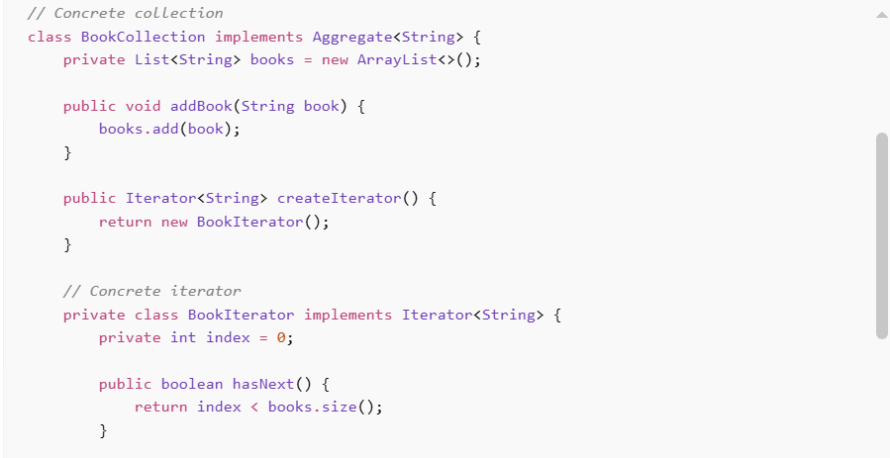
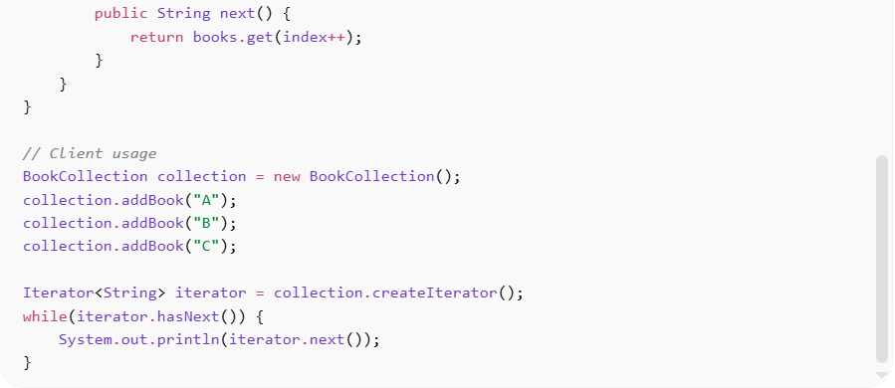
// Iterator interface
interface Iterator<T> {
boolean hasNext();
T next();
}

// Aggregate interface
interface Aggregate<T> {
Iterator<T> createIterator();
}

// Concrete collection
class BookCollection implements Aggregate<String> {
private List<String> books = new ArrayList<>();

public void addBook(String book) {
books.add(book);
}

public Iterator<String> createIterator() {
return new BookIterator();
}

// Concrete iterator
private class BookIterator implements Iterator<String> {
private int index = 0;

public boolean hasNext() {
return index < books.size();
}

public String next() {
return books.get(index++);
}
}
}

// Client usage
BookCollection collection = new BookCollection();
collection.addBook("A");
collection.addBook("B");
collection.addBook("C");

Iterator<String> iterator = collection.createIterator();
while(iterator.hasNext()) {
System.out.println(iterator.next());
}
Benefits:
• Hides internal structure of collection
• Provides uniform traversal interface
• Supports different traversal methods
• Improves code reusability

⚡ Advantages
# Source: AI Source: Provided by: [Data Path: Persons Table -> ID Column: 1, Name_En Column: Motasem Essam] -> From: [ChatGPT] on [1/23/2026]
• Promotes encapsulation
• Simplifies collection traversal
• Works with different data structures uniformly
• Allows multiple iterators simultaneously

⚠️ Disadvantages
# Source: AI Source: Provided by: [Data Path: Persons Table -> ID Column: 1, Name_En Column: Motasem Essam] -> From: [ChatGPT] on [1/23/2026]
• Adds extra classes and interfaces
• May be unnecessary for simple collections
• Slight performance overhead

🛠️ Use Cases
# Source: AI Source: Provided by: [Data Path: Persons Table -> ID Column: 1, Name_En Column: Motasem Essam] -> From: [ChatGPT] on [1/23/2026]
• Collections frameworks (e.g., Java Iterator, List, Set)
• Custom data structures – trees, graphs, linked lists
• Navigation systems – playlists, menus, file systems
• Data processing pipelines – sequential data access

